` CO1 ASSESSMENT TOOL -1

NAME :K.Divya
REG NO:192511316
COURSE:Object Oriented Analysis And Design
CODE:0307

1.Explanation
Rules of inference are logical rules used to derive a valid conclusion from given premises.
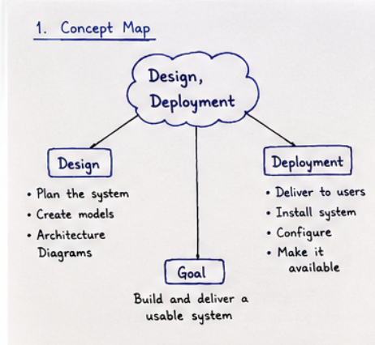

Analysis
- Identify the premises given in the question.
- Identify the conclusion that needs to be proved.
- Match the premises with a suitable rule of inference.
- Apply the rule and derive an intermediate statement.
- Continue applying valid inference rules until the required conclusion is obtained.
- If the conclusion is obtained logically from the premises, the argument is valid.
- If it cannot be derived using valid inference steps, the argument is not valid.

2.Explanation
Encapsulation means binding data and methods together, while polymorphism allows one interface to have different implementations.
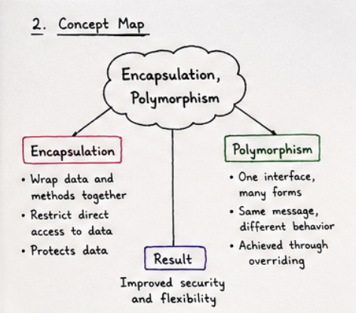

Analysis
- Identify the class and its data.
- Encapsulate data using methods.
- Identify the common interface/method.
- Apply polymorphism for different behaviours.
- Check whether the design is flexible and reusable.

3.Explanation
PCNF (Principal Conjunctive Normal Form) is a standard form of a compound proposition written as an AND (∧) of maxterms.
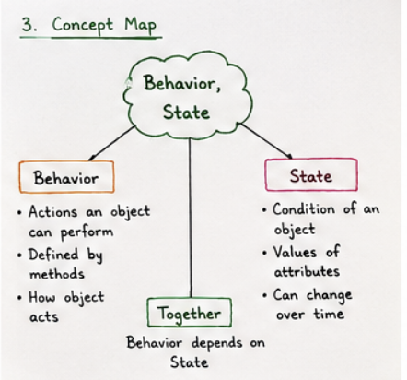

Analysis
- Identify the given compound proposition.
- Apply logical equivalences step by step.
- Convert the expression into CNF form.
- Express it as principal maxterms.
- The final expression is the required PCNF.

4.Explanation
Rules of inference help us derive a valid conclusion from given statements or premises. The conclusion is accepted when it logically follows from the premises.
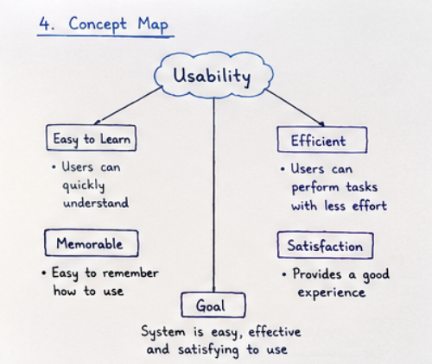

Analysis
- Identify the given premises.
- Identify the required conclusion.
- Select the suitable rule of inference.
- Apply the rule to derive the conclusion.
- Verify that the conclusion is logically valid.

5.Explanation

An equivalence relation is a relation that satisfies reflexive, symmetric, and transitive properties. If all three are satisfied, the relation is an equivalence relation.

Analysis
- Identify the set and relation given.
- Check the reflexive property.
- Check the symmetric property.
- Check the transitive property.
- If all three hold, conclude that it is an equivalence relation.

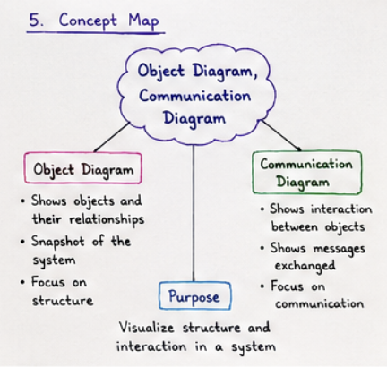

6.Explanation
Failure in Coding means errors introduced while writing the program, which can affect the correctness and quality of the code.
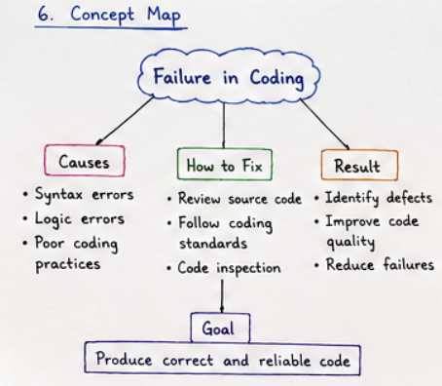

Analysis
- Identify syntax, logic, and coding errors.
- Review the source code carefully.
- Follow proper coding standards.
- Perform code inspection.
- Aim to produce correct and reliable code.

7.Explanation
Requirement Analysis and Testing help to build the right system and ensure that the system meets its requirements.
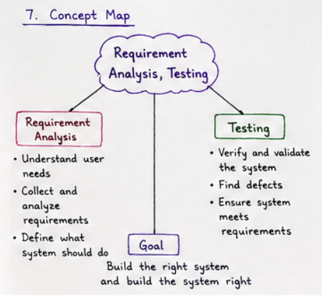

Analysis
- Understand the user needs.
- Collect and analyze requirements.
- Define what the system should do.
- Verify and validate the system.
- Find defects and ensure the system meets requirements.

8.Explanation
Object is an instance of a class. Dynamic Binding resolves a method call at runtime and supports polymorphism.
Analysis
- Identify the object.
- Identify its state and behavior.
- Understand the method call.
- Resolve the method at runtime.
- Achieve flexible and reusable code.
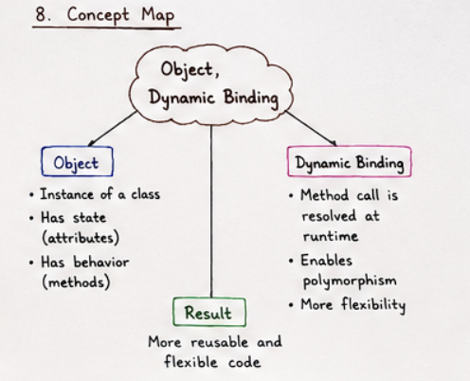

9.Explanation
Incremental Model develops the system in small increments. Agile Model uses iterative development and responds to changes.
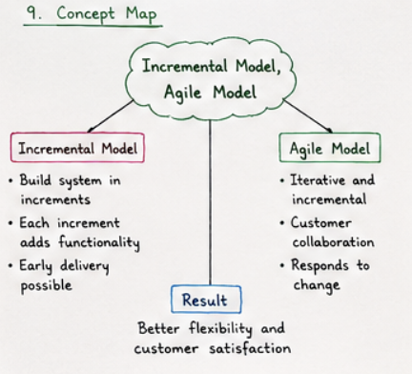
Analysis
- Divide the system into increments.
- Build and deliver each increment.
- Use iterative development.
- Encourage customer collaboration.
- Respond to changes and improve customer satisfaction.

10.Explanation
An Attribute represents the data or state of an object. A Method represents the behavior or actions of an object.
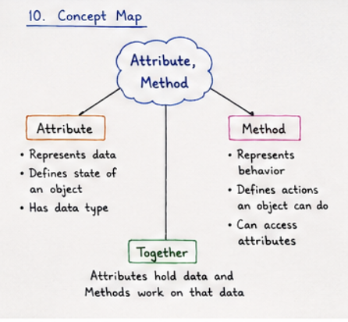
Analysis
- Identify the object's data.
- Define its attributes.
- Identify the object's behavior.
- Define its methods.
- Attributes hold data and methods work on that data.

11.Explanation
Maintainability makes a system easy to modify and fix. Scalability allows the system to grow and handle more users or data.

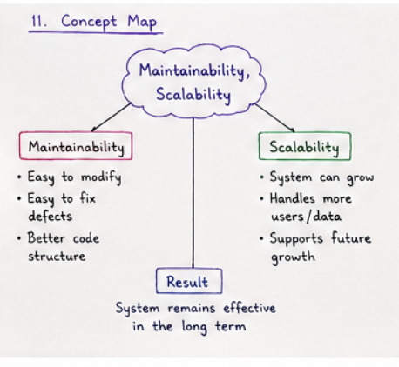
Analysis
- Make the system easy to modify.
- Make defects easy to fix.
- Maintain a better code structure.
- Support increasing users and data.
- Ensure the system remains effective in the long term.

12.Explanation
Failure in Integration occurs when different components do not work together properly.
Analysis
- Identify interface mismatches.
- Check for data inconsistency.
- Identify incompatible components.
- Perform integration testing and verify interfaces.
- Ensure all components work together as one reliable system.

